 |  |  |  | DISTRIBUTION
PROJECT | UNR-Mathewson | REPORT # | 001
LOCATION | Reno, NV | TRIP DATE | 9/27/23
PROJECT # | A9941.01 | ENGINEER/Observer | Anand Mourougassamy
CLIENT | LMN Architects | TODAY’S DATE | 9/28/2023
CONTRACTOR | Clark Construction | PAGE | 1 OF 4

OBSERVATIONS/ACTIVITY
Time: 9:00 am
Weather: Clear and 80 °F
Present: Clark Construction – Brian Peart, Chase Johnson
Magnusson Klemencic Associates – Hannah Bonotto, Anandharam Mourougassamy

Clark and MKA walked the UNR-Mathewson site to observe the reinforcement in the mat foundation and the water tank foundation, as shown in Figures 1 and 2, prior to the placement of Pour 1 concrete.

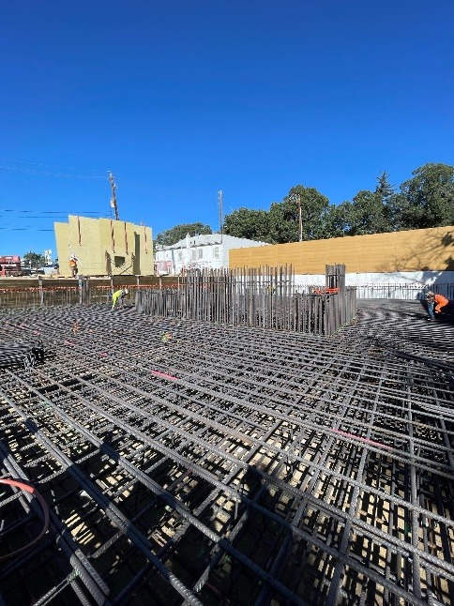
Figure 1. View looking north-west of mat reinforcement and core 1 dowels at Pour 1
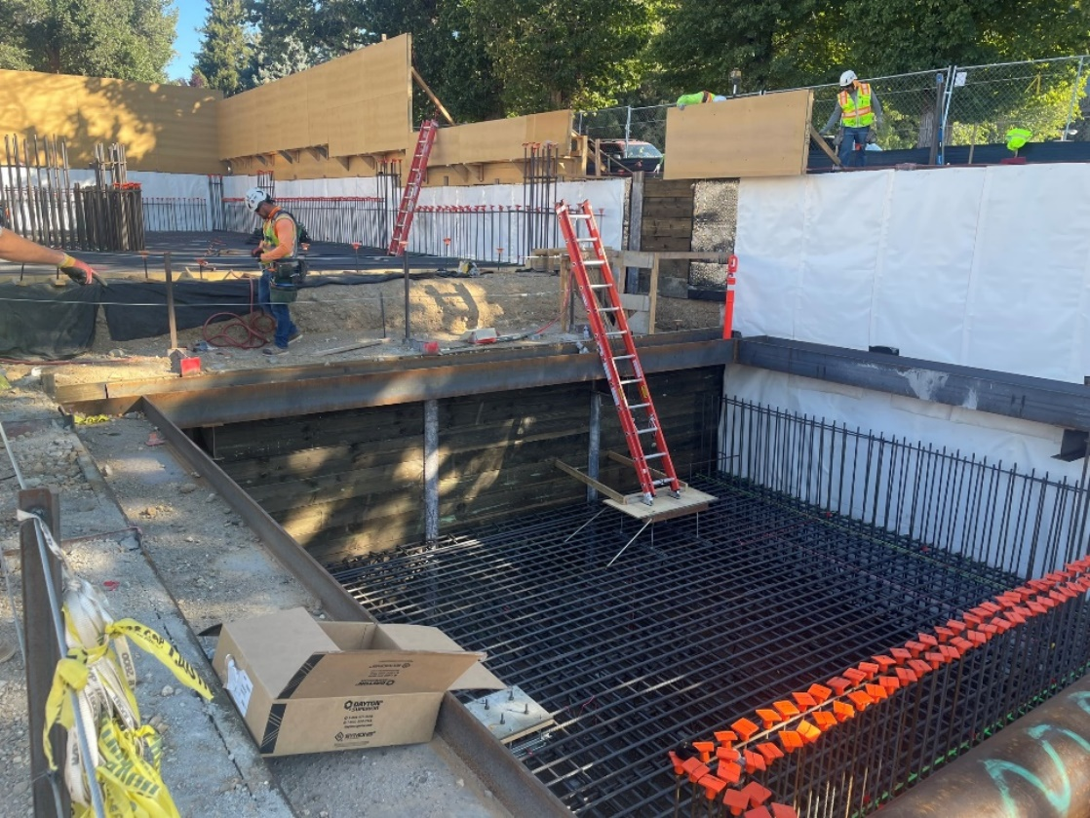
Figure 2. View looking north-east of water tank mat reinforcement at Pour 1

- MKA observed the mat reinforcement at mat between grids 2 and 4 and grids A and D.1. The top and bottom layers of reinforcement were in place. Vertical reinforcement was being installed during the visit. Reinforcement observed appeared to be in conformance with contract documents.  Action: None | 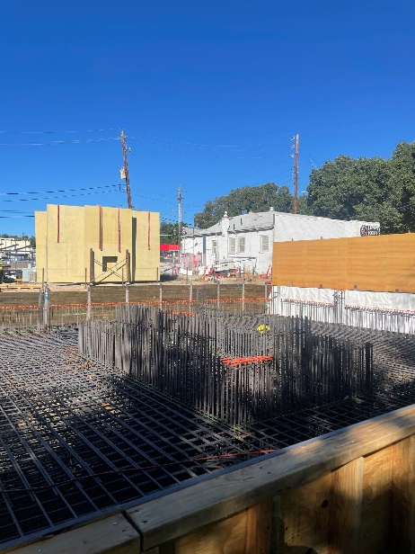  Figure 3. View looking down at mat 1 from south-east corner
- MKA observed the thickness of the north wall on grid 2 to be less than 12” and wall vertical reinforcement not located per structural drawings.  Action: Contractor to submit RFI with as-built condition of the north wall showing reinforcement location, concrete outlines as it relates to structural drawings  Contractor to also provide Clark proposed locations for steel column and base plates above concrete pilasters on Grid 2 in the forthcoming RFI. | 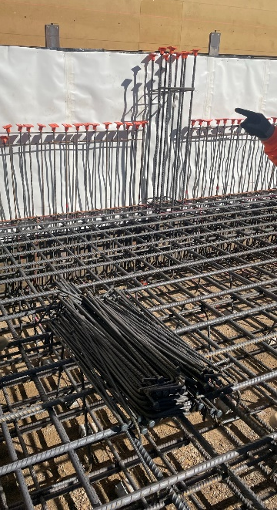  Figure 4. View looking at the vertical reinforcement at north wall on grid 2
- MKA observed concrete cover of the vertical bars at north wall on grid 2 might be larger than 2” on the outside face and 1” on the inside face  Action: Contractor to confirm minimum of 2” cover on the outside face to the waterproofing and 1” on the inside face of vertical reinforcement. | 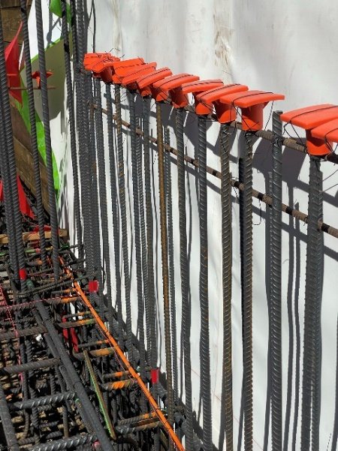  Figure 5. View looking down at wall reinforcement along grid 2
- MKA observed the vertical reinforcement at pilasters on grid A/6.2, A/8, B/8 to not meet the 12” max spacing between vertical bars requirement per note 4 on detail 4/S411.  Action: Contractor to provide an additional vertical bar along N-S face of the (3) pilasters to meet the 12” max spacing requirement. | 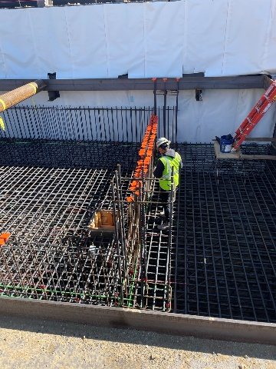  Figure 6. View looking down at pilaster on grid B/8

I:\UNR_Mathewson\Construction Admin\FieldReports\20230927_UNR_MKA Construction Observation Report_001.docx

